**Titanic Data Analysis**

**Write a mapreduce program to find out number of males and females died in the titanic tragedy and save the output in KeyValue Output format. Download the Titanic data set from the below link Titanic_Dataset**

**DATA SET DESCRIPTION**

**Column 1 : PassengerId**

**Column 2 : Survived (survived=0 & died=1)**

**Column 3 : Pclass**

**Column 4 : Name**

**Column 5 : Sex**

**Column 6 : Age**

**Column 7 : SibSp**

**Column 8 : Parch**

**Column 9 : Ticket**

**Column 10 : Fare**

**Column 11 : Cabin**

**Column 12 : Embarked**

**Program:**

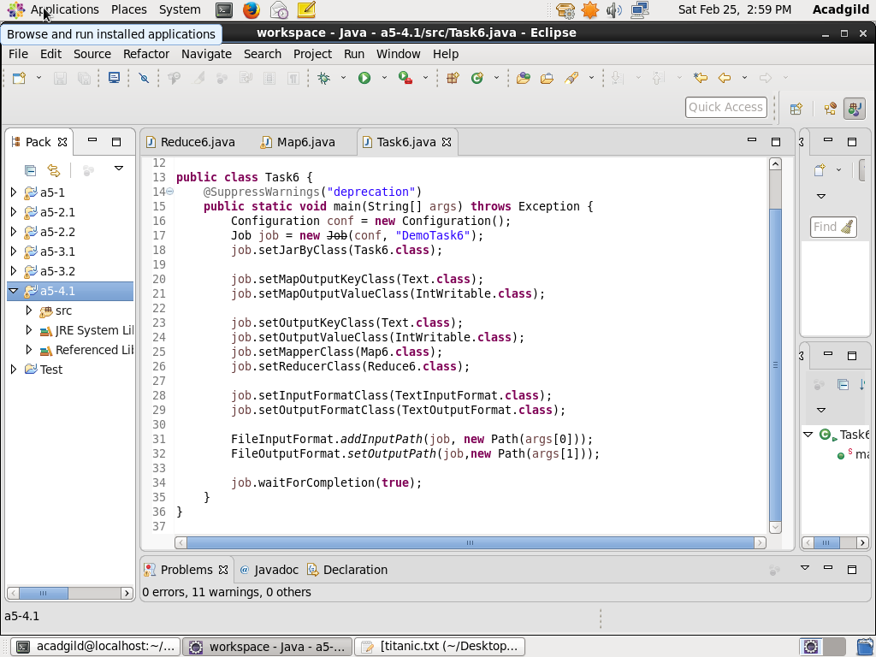

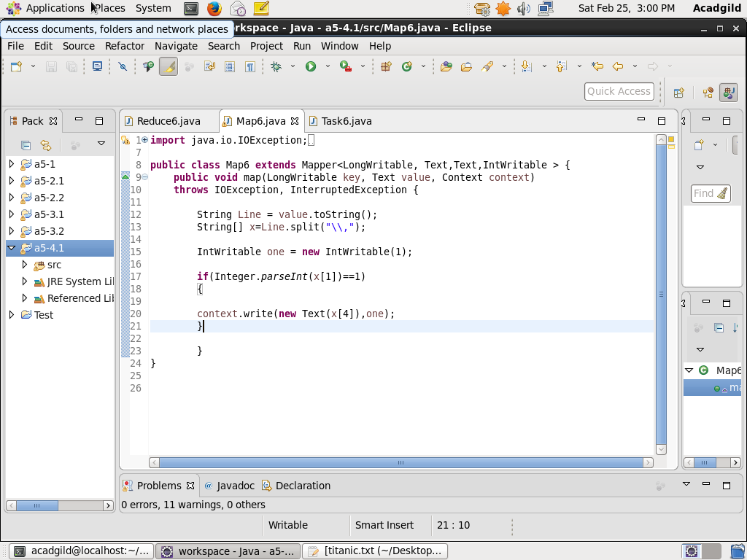

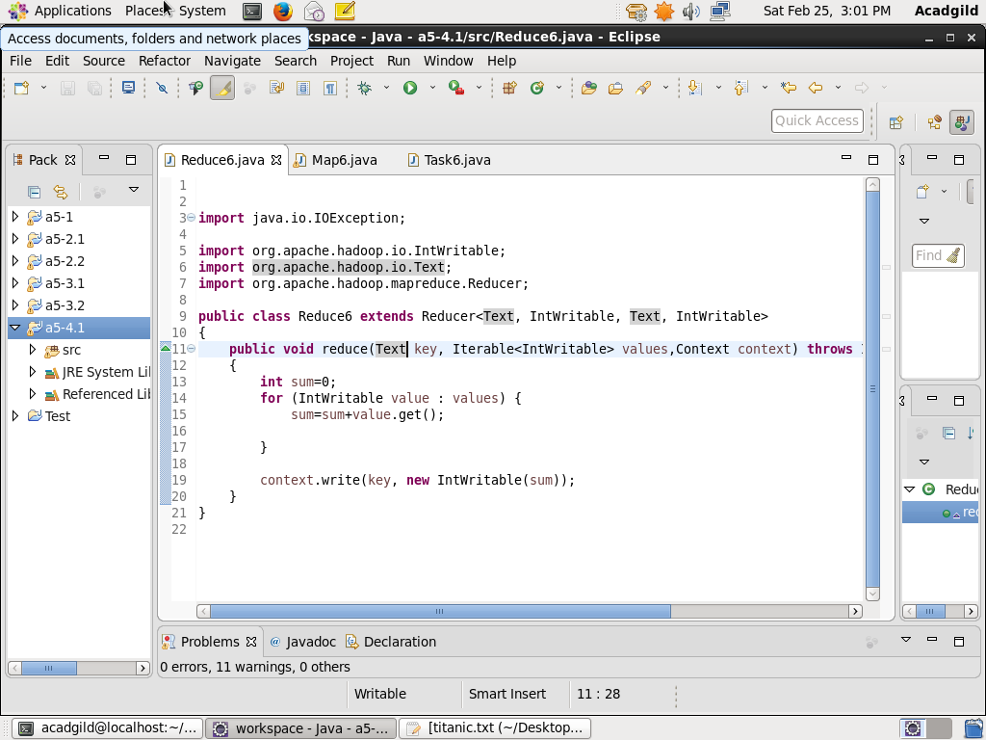

**Output:**

